Robert Chesser

Homework 5

8/17/19

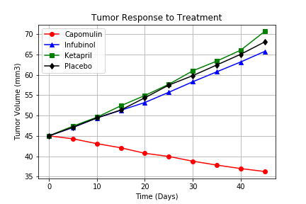

1. This first graph shows that there isn’t a significant difference between the placebo and two of the selected drugs on this chart. The drug Capomulin appears to be quite effective when compared to the placebo and Infubinol and Ketapril.

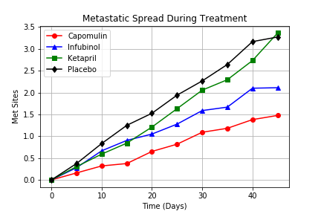

1. The drug Infubinol and Capomulin appear to show a reduction of metastatic site spread during treatment when compared to the placebo. The percent of change relative to the placebo could be quantified by further analysis.

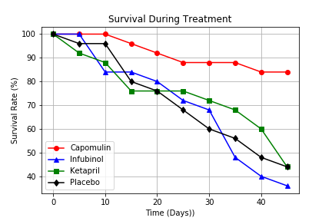

1. The only drug to show a significant improvement in survival rates relative to the placebo is Capomulin. Even at the final interval, the subjects receiving Capomulin had an 85% survival rate. The next highest survival rate is only 45%.

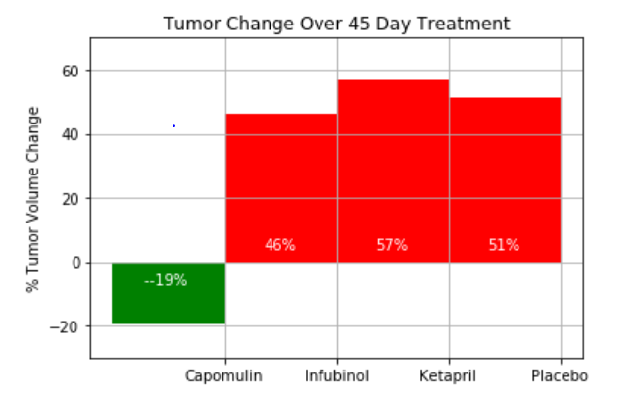

1. The final graph just reaffirms the other three views into the data. The drug Capomulin appears to be effective in treating tumors and preserving life while the other drugs charted in the above examples only follow a similar path to that of the placebo.